English First Additional Language
Grade 8
Term 3 – Language Test
2013

Contents
- Comprehension (20)
- Summary (10)
- Language (20)

Instructions
- Write your name and surname on the answer sheet.
- Answer every question.
- Leave a line open between each answer.
- Begin the answer of each section on a new page.
- Staple your answers to the front of the question paper

SECTION A – COMPREHENSION
Pre-reading:
Raesibe is going to play in the school play. She is excited and tells her friends. She is going to perform in The Merchant of Venice, a play by William Shakespeare. She gives extra information about William Shakespeare and the time he lived.

Glossary
Racism – judging people on the grounds of their race
Ambition – a strong desire to achieve something
Performance – something done in front of an audience
Tragedy – story with a sad ending.

During Reading
Read the passage:

It’s Show time!!
Raesibe was bursting with excitement. She had to tell someone her news. As she ran down the corridor towards the Maths room she bumped into Nick.
“Hey, slow down,” laughed Nick, “What is the big hurry? It is only Maths next and we have got plenty of time.”
“Oh, Nick,” she gasped. “I have got a part in the school play.”
Nick looked at her with raised eyebrows. “What school play?” he asked.
“Remember last week I went to an audition for a part in the senior play? The drama club is putting on The Merchant of Venice because it is a play the Grade 12s have to study.”
“Oh, yes. It is just that Shakespeare is not interesting to me. I think all that old-fashioned stuff is boring and I do not understand it anyway. Why can’t they just speak in modern English instead of…”
Nick tailed off as he saw Raesibe’s disappointed face.
“Nick, just because Shakespeare wrote his plays over 400 years ago does not mean that they are out of date. His plays are about all sorts of modern ideas such as racism and greed and jealousy and ambition and and…” Raesibe could see the confusion on Nick’s face. “Ok, I know that most kids our age prefer modern entertainment, but I have been reading about Shakespeare and his times and I think some of his plays are really cool. Look at this list of interesting facts about those times.”

Did you know?
- Shakespeare was born in England in 1564, over 440 years ago.
- Shakespeare wrote plays and poems. His most famous plays include tragedies like Hamlet and Macbet , and comedies, like A Midsummer Night’s Dream and The Merchant of Venice.
- One of the first theatres was called the Globe Theatre. It was made entirely of wood and thatch, and it was burnt to the ground in 1613. It was rebuilt exactly where it had stood in 1990, where visitors to London can attend performances.
- Plays were performed every afternoon, Monday to Saturday. On a good day about 3000 people could attend a popular show. They knew there was a performance when a white flag was flown from the roof of the theatre.
- People paid one penny to stand in front of the stage.

“So you see, Nick,” continued Raesibe, “everyone loves to be entertained, even people living 400 years ago. And that’s why I’m so excited. I’ve got a part in a play that is so old, but it is still about things which are important today.”

Post-Reading
Answer the following questions based on the reading passage:
  - What is the name of the play that Raesibe is going to play in?
The Merchant of Venice
(1)
1.2 Nick and Raesibe are on their way to which class?
Maths
(1)
1.3 What did Raesibe have to do to get a part in the play?
She had to go for an audition
(1)
1.4 Who is putting on the play?
The drama club
(1)
1.5 Why are they putting on the play?
It is a play the gr 12s have to study.
(2)
1.6 How many years ago did Shakespeare write his plays?
Over 400 years ago
(1)
1.7 Is The Merchant of Venice a comedy or a tragedy?
comedy
(1)
1.9 Why was did the first theatre, The Globe Theatre, burn down so easily?
It was entirely made of wood and wood burns easily
(2)
1.10 Why would a theatre raise a white flag on its roof?
The white flag was flown to show that there was a performance
(2)
1.11 What was the advantage of paying a penny for a performance?
If you paid a penny you could stand in front of the stage.
(1)
1.12 What modern entertainment do you prefer?
Open ended answer
(1)
1.13 How does Nick feel about performing in a play?
We are unsure, he does not like Shakespeare but we don’t know if he would actually like to perform in a play.
(1)
1.14 How do Raesibe’s feelings differ from Nick’s feeling about performing in a play?
Raesibe is very excited about it.
(1)
1.15 Do you think Raesibe is right when she says “everyone loves to be entertained”? Give a reason for your answer.
Open ended answer. Must be a reason
(2)
1.16 Do you agree with Nick when he says “I think all that old-fashioned stuff is boring”? Give a reason for your answer.
Open ended answer – must be a reason.
(2)
[20]
SECTION B – SUMMARY
QUESTION 2
Read the following passage.

- Make a list of seven methods by which teens entertain themselves
- Number your list from 1-7.
- Use 60 words.
- Indicate the number of words at the end of your summary.
(10)

Teenagers of late are so very much addicted to their television and radio sets since those have been the main forms of entertainment for the last four or five decades. They love watching TV so much because it telecasts many entertainment programs that help teenagers spend some time with ease and relax.
iPods, MP3 and MP4 players are the latest means of entertainment for teenagers. You would find teens with their portable music players, while travelling in the bus, train or even while walking down the street.
Movies, Theatres and Concerts are some of the oldest forms of entertainment for teenagers. Visiting the movies or theatres with friends would be the ultimate solution for time passing, and you would sometimes be able to observe teens skipping their classes and visiting the movies. Concerts are also highly preferred by most teenagers as they would love to see their favourite bands and artists perform live in front of them.
Clubbing and Partying can be said to be the most preferred form of entertainment amongst teenagers. Getting together with their friends and going to night clubs and karaoke arenas are a common practice. Most of the clubhouses and party houses do host parties and events targeted at teens, also known as teen nights or teen's only parties.
Sporting and Gaming (especially through the internet) is another form of entertainment for teenagers. Playing sports like basketball, baseball, soccer, football, cricket, badminton and tennis are some of the favourites among most teenagers. However, as these games can now be played virtually through computers and play stations or gaming consoles. (264 words)

- They love watching television
- They listen to iPods, MP3 and MP4 players.
- They like to go to movies, theatres and concerts.
- In concerts they can see their favourite bands and artists.
- Clubbing and partying is most preferred by teenates.
- They like to go to night clubs and karaoke arenas.
- Teenagers like sporting and gaming
- Sports like basketball, baseball, soccer, football
and cricket and badminton is much fun.
- Games can also be played virtually on computers.

SECTION C – LANGUAGE
Read the following advertisement and answer the language questions that follow:
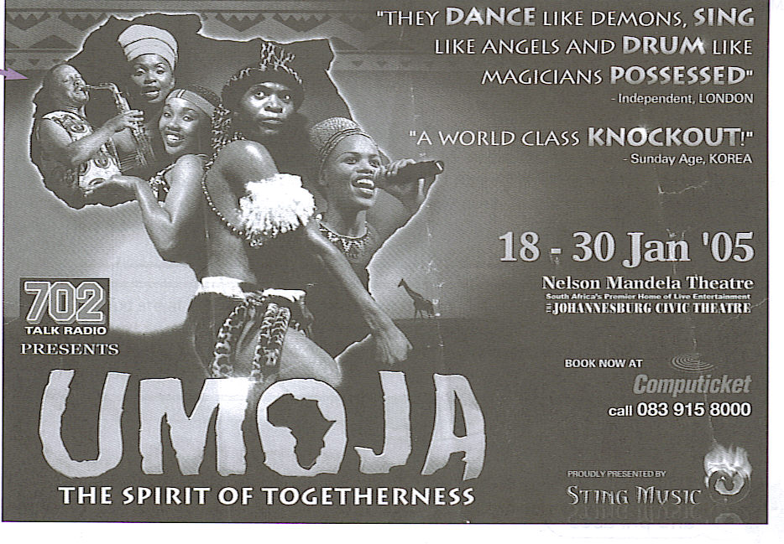

3.1 They dance like demons, sing like angels and drum like magicians possessed.
(1)
3.2 A world class knockout
(1)
3.3 C Only “dance”, “sing” and “drum” are verbs
(1)
3.4 4.4.1 more
4.4.2 most
(2)
3.5 -ness
(1)
3.6 Dislike/unlike
(1)
3.7 3.7.1 mother-in-law
3.7.2 breakfast
3.7.3 boyfriend
3.7.4 happy-go-lucky
3.7.5 chickenpox
(5)
3.8 The performance is a huge success
(2)
3.9 The spirit of togetherness
(1)
3.10 To say the comments have been made by somebody else.
(2)
3.11 B: Magicians are?
(1)
3.12 Dance like demons
(2)
(20)
[50]

Test 2 – Literature
Total: 30

Instructions
- Answer all the questions.
- Leave a line open between each answer.
- Write your name and surname on the answer sheet.
- Begin the answer to each section on a new page.

SECTION A – POETRY
Ordinance on Arrival
Welcome to you
Who have managed to get here.
It’s been a terrible trip;
You should be happy to have survived it.
Statistics prove that not many do. 5
You would like a bath, a hot meal,
A good night’s sleep. Some of you
Need medical attention.
None of this is available.
These things have always been 10
In short supply; now
They are impossible to obtain.

This is not
A temporary solution;
It is permanent. 15
Our condolences on your disappointment.
It is not our responsibility
Everything you have heard about this place
Is false. It is not our fault
You have been deceived, 20
Ruined your health getting here.
For reasons beyond our control
There is no vehicle out.

  - Why is it a sad poem?
People died on the journey and in the end they did not get the help they thought they would get.
(2)
4.2 Describe the journey that the refugee in the poem must have made to get to this place.
It was a terrible journey. There was no food.
(2)
4.3 What are statistics?
It refers to research results or numbers.
(1)
4.4 What is bad about describing people using statistics?
People become impersonal like the numbers and you don’t care.
(2)
4.5 What does the refugee look forward to in his new country?
A bath, food to eat, medical treatment, a place to sleep.
(2)
4.6 The refugee gets nothing from his new country, not even medical attention. Why not?
The country does not want them there. It is not that country’s responsibility to look after them.
(2)
4.7 What excuse does the official give for this?
The things they want are impossible to obtain. It is not their responsibility to look after them.
(2)
4.8 Which of the words below best describe the attitude of the official to the refugee?
Generous, kind, unsympathetic, unfeeling, warm, welcoming.
(2)
(15)
SECTION B – KATY OF SKY ROAD

Read the following extract from Katy of Sky Road and answer the questions that follow:

“Katy, come! You’re going to miss it.”
“We’re still busy,” Wesley snaps, but Melissa isn’t listening.
“Make ‘an!” she demands.
“Thank you. That will be all for today,” Mr Samuels says, exasperated, “I will see you next week.”
Melissa chases me on as I struggle out of my dance shoes and force my feet into my school shoes without bothering to untie the laces.
“What is it?” I ask her as she pulls me out of the classroom.
“You’ve got to check this…”
Running ahead of me and babbling so fast that I can’t make out her words. She leads me to the other side of the school grounds, where the teachers park their cars. A group of kids is gathered around a ghetto-blaster with 50 Cent and Tupac rapping at the top of their lungs – All eyes on me. People are swaying and beat-boxing along with the music. Out of breath, Melissa pulls me to the front of the crowd.
The new boy; the one everyone is talking about, is dancing in the middle, but breakdancing like I have never seen before. His body bends in every direction until he is writhing like a snake, just above the ground, balancing on his feet, bent at the knee and flaying his arms, his shoulders doing a dance sequence of their own until I think they will come unhinged. The crowd shrieks as he spins on his heels.
For a moment our eyes meet and I feel compelled to join him, but I restrain myself. This is his show.
Yet I find my body obeying the rhythm. I move my hips, my arms. I struggle to keep my feet firmly planted to the spot. This is not my show.
“You can do that,” Melissa says excitedly and gives me a deliberate shove towards the boy.

  - Wesley has two sides to his characters.
    - Describe the good Wesley.
He is a prefect. He does ballroom dancing. He attends youth meetings at the church. He if polite towards adults and shows good manners.
(3)
    - Describe the bad Wesley.
He is extremely jealous of Katy. He sells tik to Zeke and other people. He forces Katy to be with him. He kidnaps her. He gets very angry.
(3)
5.2 Who is Mr Samuels and how does Katy disappoint him?
Mr Samuals is the ballroom dance instructor. Katy decides to stop with ballroom dancing.
(2)
5.3 Describe Melissa’s character.
Although she is a good friend she smokes. She does not care about school. She throws away her report card. She encourages Katy to lie to her father.
(3)
5.4 Katy is going to dance with this strange boy on the playground.
5.4.1 What is his name?
Ricardo
(1)
5.4.2 Describe how the relationship between Katy and this boy develops.
Ricardo asks her to dance with him in a competition. Katy gives him something to show him he can trust her. He gives Katy his rain jacket. Ricardo is always concerned about her safety. When Katy is in deep trouble she phones Ricardo. They win the dance competition. They seem to be in love.
(3)
(15)
[30]

